Report for

EE/CS 120B Intro to Embedded System

Custom Project: Simon Game

Lab Section: B21

TA: Ekta Gujral

Prepared by

Minseop Kim

(862058470)

**Description/Introduction of Project:**

The logic of Simon game was created on this project by Atmel Studio software tool and Atmega1284 Micro-controller. To play this game, we need to memorize the random LED flashing sequential pattern on the LED and press the button by given sequence. We assume that if 9 buttons were pressed correctly at the end by given sequence, player wins the game. Otherwise, player loses the game. The LCD screen will display and report scores, win/lose and notification that when the game starts and ends.

**Detail of Project:**

* *Components*

The components for this project are 4 LEDs, 5 buttons (4 buttons for pressing sequence to play game and 1 button for beginning new game), LCD screen, jumper cables or wires, Atmega1284 Micro-controller, 2 ceramic capacitors, 4 resistors and 1 potentiometer as shown below in Figure 1.

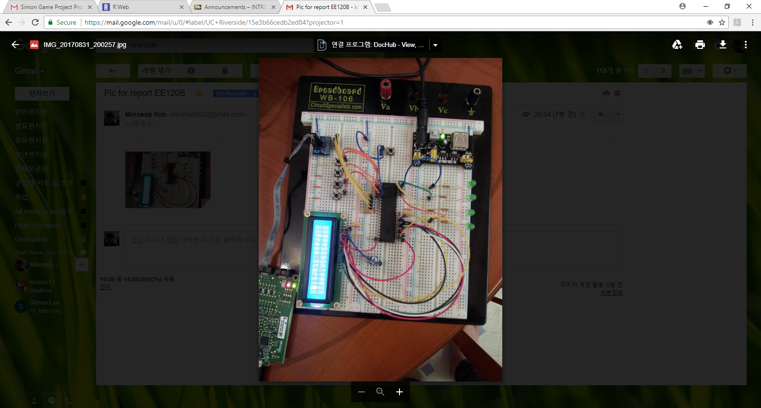

Figure 1. Circuit for Simon game project

* *How to play it*

Once the game starts, you need to remember the sequential pattern lighted on the LED light and getting it by pressing the buttons. For each continuous round and multiple rounds, the short explanation above will be repeated and increment the pattern by one, so it will make this game more difficult as it continues. When you press wrong button, you will lose. On the other hand, if you press the correct button until 9 sequences, you will win. The LCD display will report your scores and notification that you win or lose.

* *State Machine for Project*

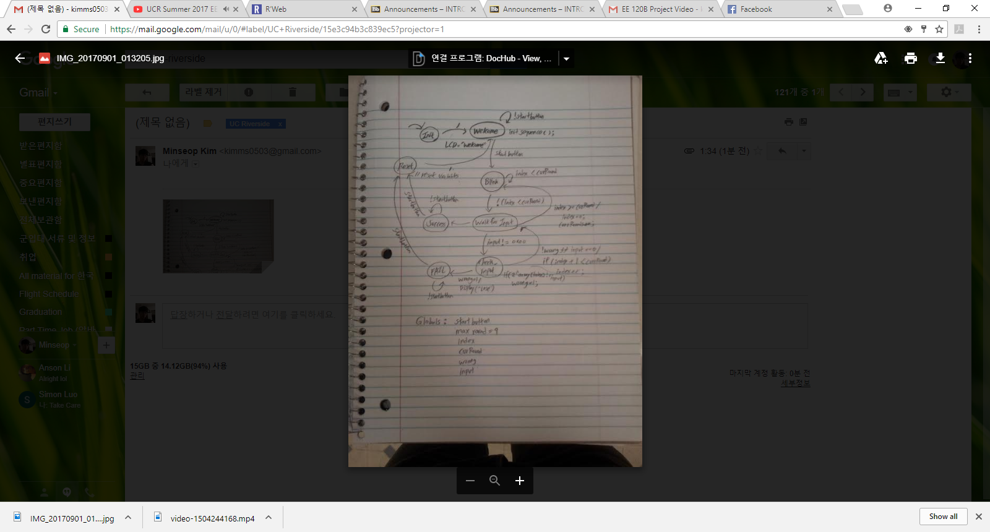

Figure 2. State Machine for Simon game project

* *Challenge to initiate Project*

There is the latency between 4 buttons pressed by player and 4 LEDs while this project has been processed. When it gets input sequences, the latency gave a little pause between button pressed and the blinking LED. To improve this, the period has been lowered by 100ms but this was fast to recognize the blinking LED sequences to remember as a player.

**Conclusion:**

In this lab, we created a special purpose timer by using the FPGA application. We performed Parts A and C of the lab. We then implemented a laser surgery system on the Basys development board. We facilitate the implementation of each part of the lab and set the given constraints on ‘ucf’ file. After we obtained ‘.bit’ file by generating programming file, we uploaded this file to the Basys board by using Adept Export software.